COURSE NAME: Principals of Programming
LECTURE TOPIC / MODULE: Introduction to Programming Concepts / Module 1
DATE(S): 08.11.25 – 08.17.25
INSTRUCTOR: Steven Evans
KEY CONCEPTS:
- Examine different decision control statements in Python.
- Implement a Python if-else statement.
- Test the use of Python relational operators.
- Deconstruct an application involving compound relational operators.
DEFINITIONS:
- A branch is a program path taken only if an expression's value is true.
  - Ex: A hotel may discount a price only for people over age 60.
- Such a branch is commonly known as an If branch: A branch taken only if an expression is true.
- An if-else structure has two branches: The first branch is taken if an expression is true, else the other branch is taken.
  - statement executes one group of statements when an expression is true and another group of statements when the expression is false.
- An if statement executes a group of statements if an expression is true. The statements in a branch must be indented some number of spaces, typically four spaces.
- The equality operator == evaluates to true if the left side and right side are equal.
  - Ex: If num_years holds the value 10, then the expression num_years == 10 evaluates to true.
- A branch's statements can include any valid statements, including another if-else statement, which are known as nested if-else statements.
- An equality operator checks whether two operands' values are the same (==) or different (!=).
  - Note that equality is ==, not just =
- A Boolean is a type that has just two values: True or False.
  - An expression involving an equality operator evaluates to a Boolean value.
  - A Boolean operator treats operands as True or False and evaluates to a value of True or False. Boolean operators include and, or, and not.
  - A Boolean expression is an expression using Boolean operators.
- A relational operator checks how one operand's value relates to another, like being greater than.
- Operator chaining. For example, a < b < c determines whether b is greater-than a but less-than c. Chaining performs comparisons left to right, evaluating a < b first.
- The in and not in operators, known as membership operators, yield True or False if the left operand matches the value of some element in the right operand, which is always a container.
  - Membership operators can be used to check whether a string is a substring, or matching subset of characters, of a larger string.
    - For example, 'abc' in '123abcd' returns True because the substring abc exists in the larger string.
- The programmer can use the identity operator, is, to check whether two operands are bound to a single object. The inverse identity operator, is not, gives the negated value of 'is'. Thus, if x is y is True, then x is not y is False.
- The order in which operators are evaluated in an expression is known as precedence rules.
- A code block is a series of statements that are grouped together.
- A conditional expression has the following form:
  - expr_when_true if condition else expr_when_false
    - A conditional expression has three operands and thus is sometimes referred to as a ternary operation.
FORMULAS / NOTES:
- Good Practice is to be as explicit as possible and reduce the chances of logical errors by using the less-than-or-equal-to rather than just less-than. Thus, the constant is the number of relevance, e.g., less-than-or-equal-to 39 rather than less-than 40, because 40 is not the relevant number.
- Sometimes the programmer has multiple if statements in sequence, which looks similar to a multi-branch if-else statement but has a very different meaning. Each if statement is independent, and thus more than one branch can execute.
- Numbers are arithmetically compared.
- Strings are compared by converting each character to a number value (ASCII or Unicode), and then comparing each character in order. Most string comparisons use equality operators "==" or "!=", as in today == 'Friday'.
- Lists and tuples are compared via an ordered comparison of every element in the sequence. Every element between the sequences must compare as equal for an equality operator to evaluate to True. Relational operators like < or > can also be used: The result is determined by the first mismatching elements in the sequences. For example, if x = [1, 5, 2] and y = [1, 4, 3], then evaluating x < y first evaluates that 1 and 1 match. The next elements do not match, so 5 < 4 is evaluated, which produces a value of False.
- Dictionaries are compared only with == and !=. To be equal, two dictionaries must have the same set of keys and the same corresponding value for each key.
- True and False are keywords in Python and must be capitalized.
- Membership in a dictionary implies that a specific key exists in the dictionary. A common error is to assume that a membership operator checks the values of each dictionary key as well.
- Identity operators do not compare object values; rather, identity operators compare object identities to determine equivalence. Object identity is usually ¹ the memory address of an object.
- Good practice is to use the standard recommended 4 columns per indentation level.
- A good practice is to use spaces only when indenting code, and to set text editor options to automatically use spaces when possible.
- Good practice is to use the widely accepted standard of 80 columns. A few exceptions to the rules of indentation deal with very long statements that require more than one line and wrap to the next line. Such special situations do not indicate new code blocks.
- Good practice is to restrict usage of conditional expressions to an assignment statement, as in: y = 5 if (x == 2) else 9*x.
EXAMPLE(S) / ILLUSTRATION(S):
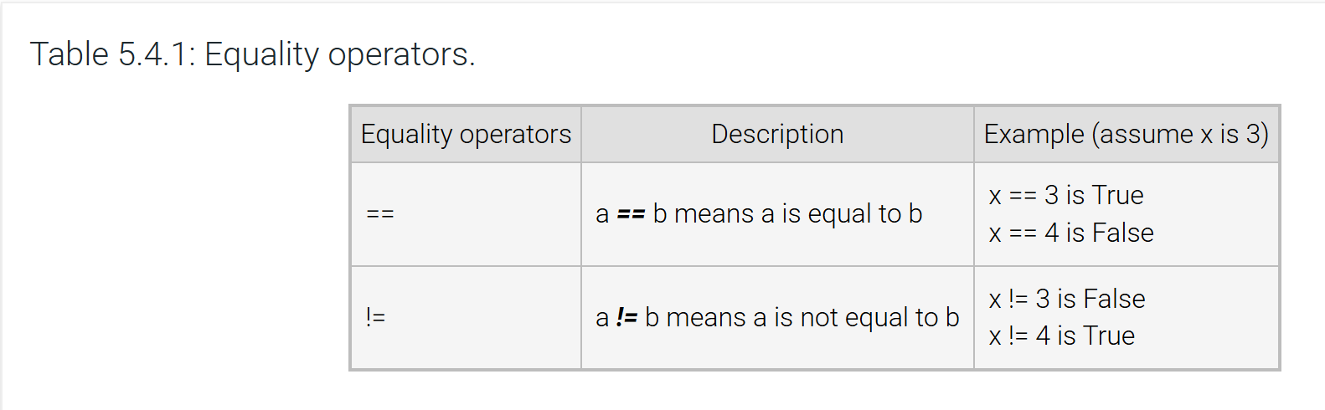
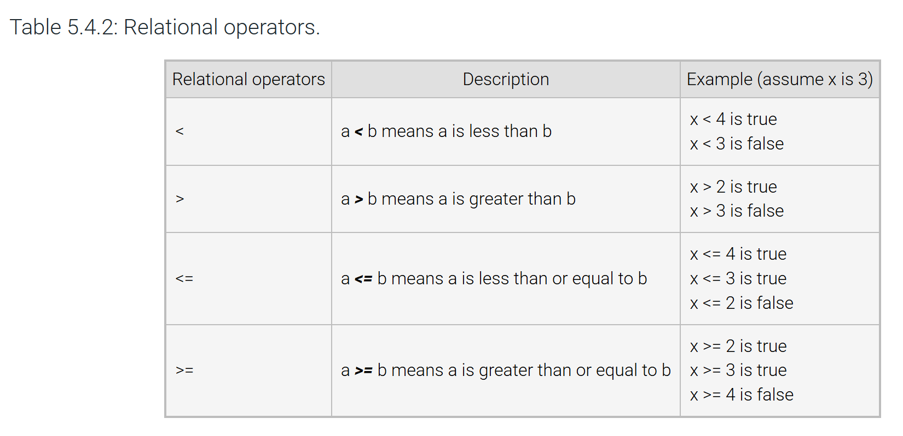
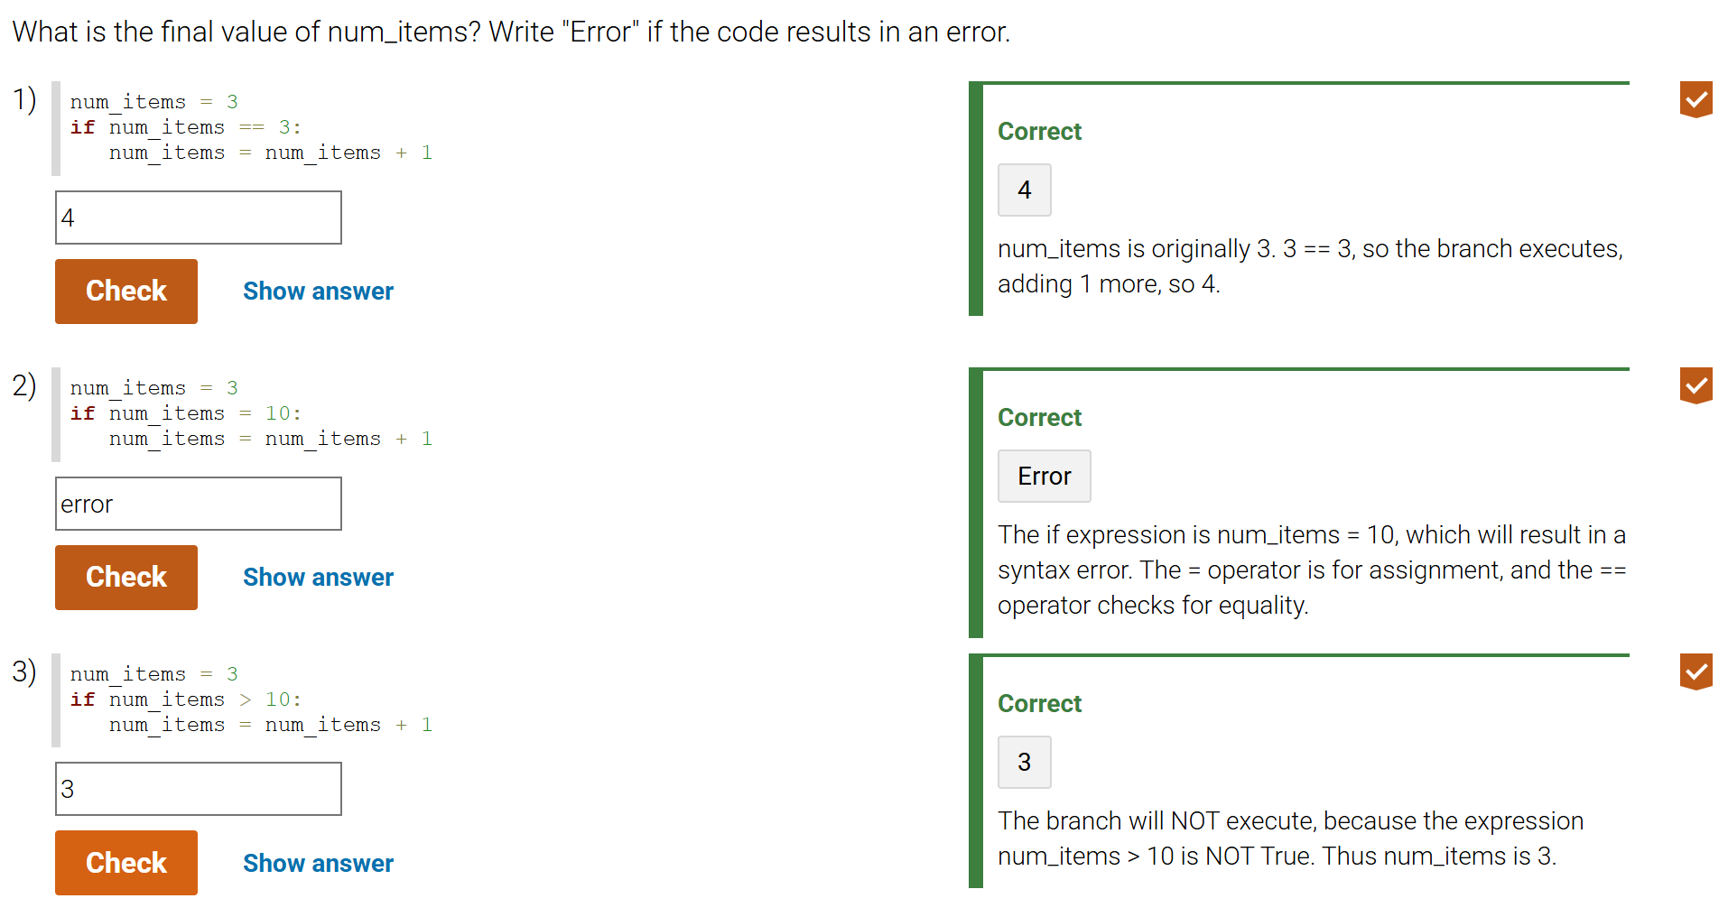
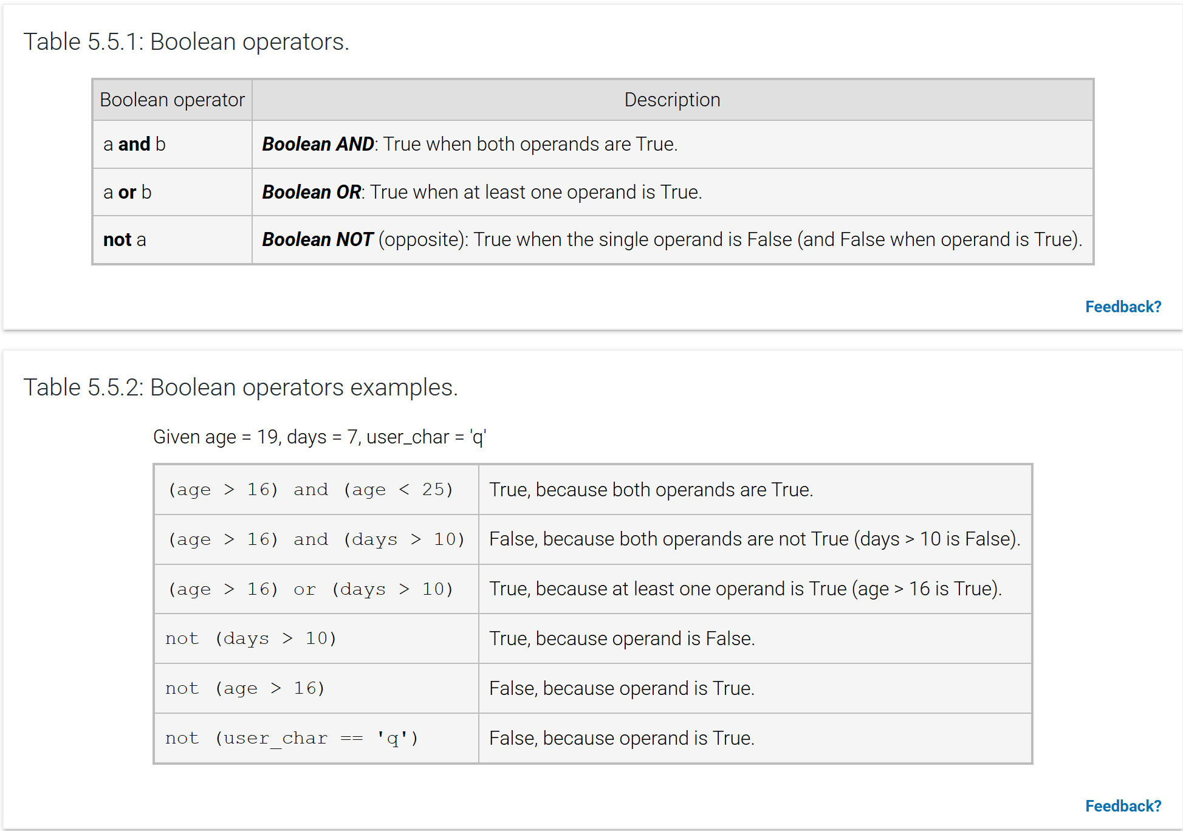
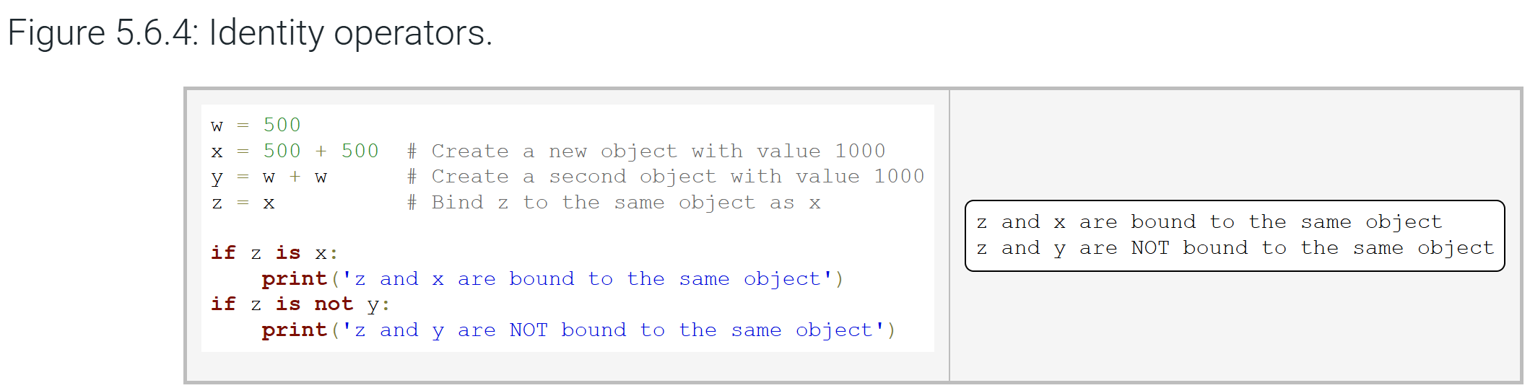
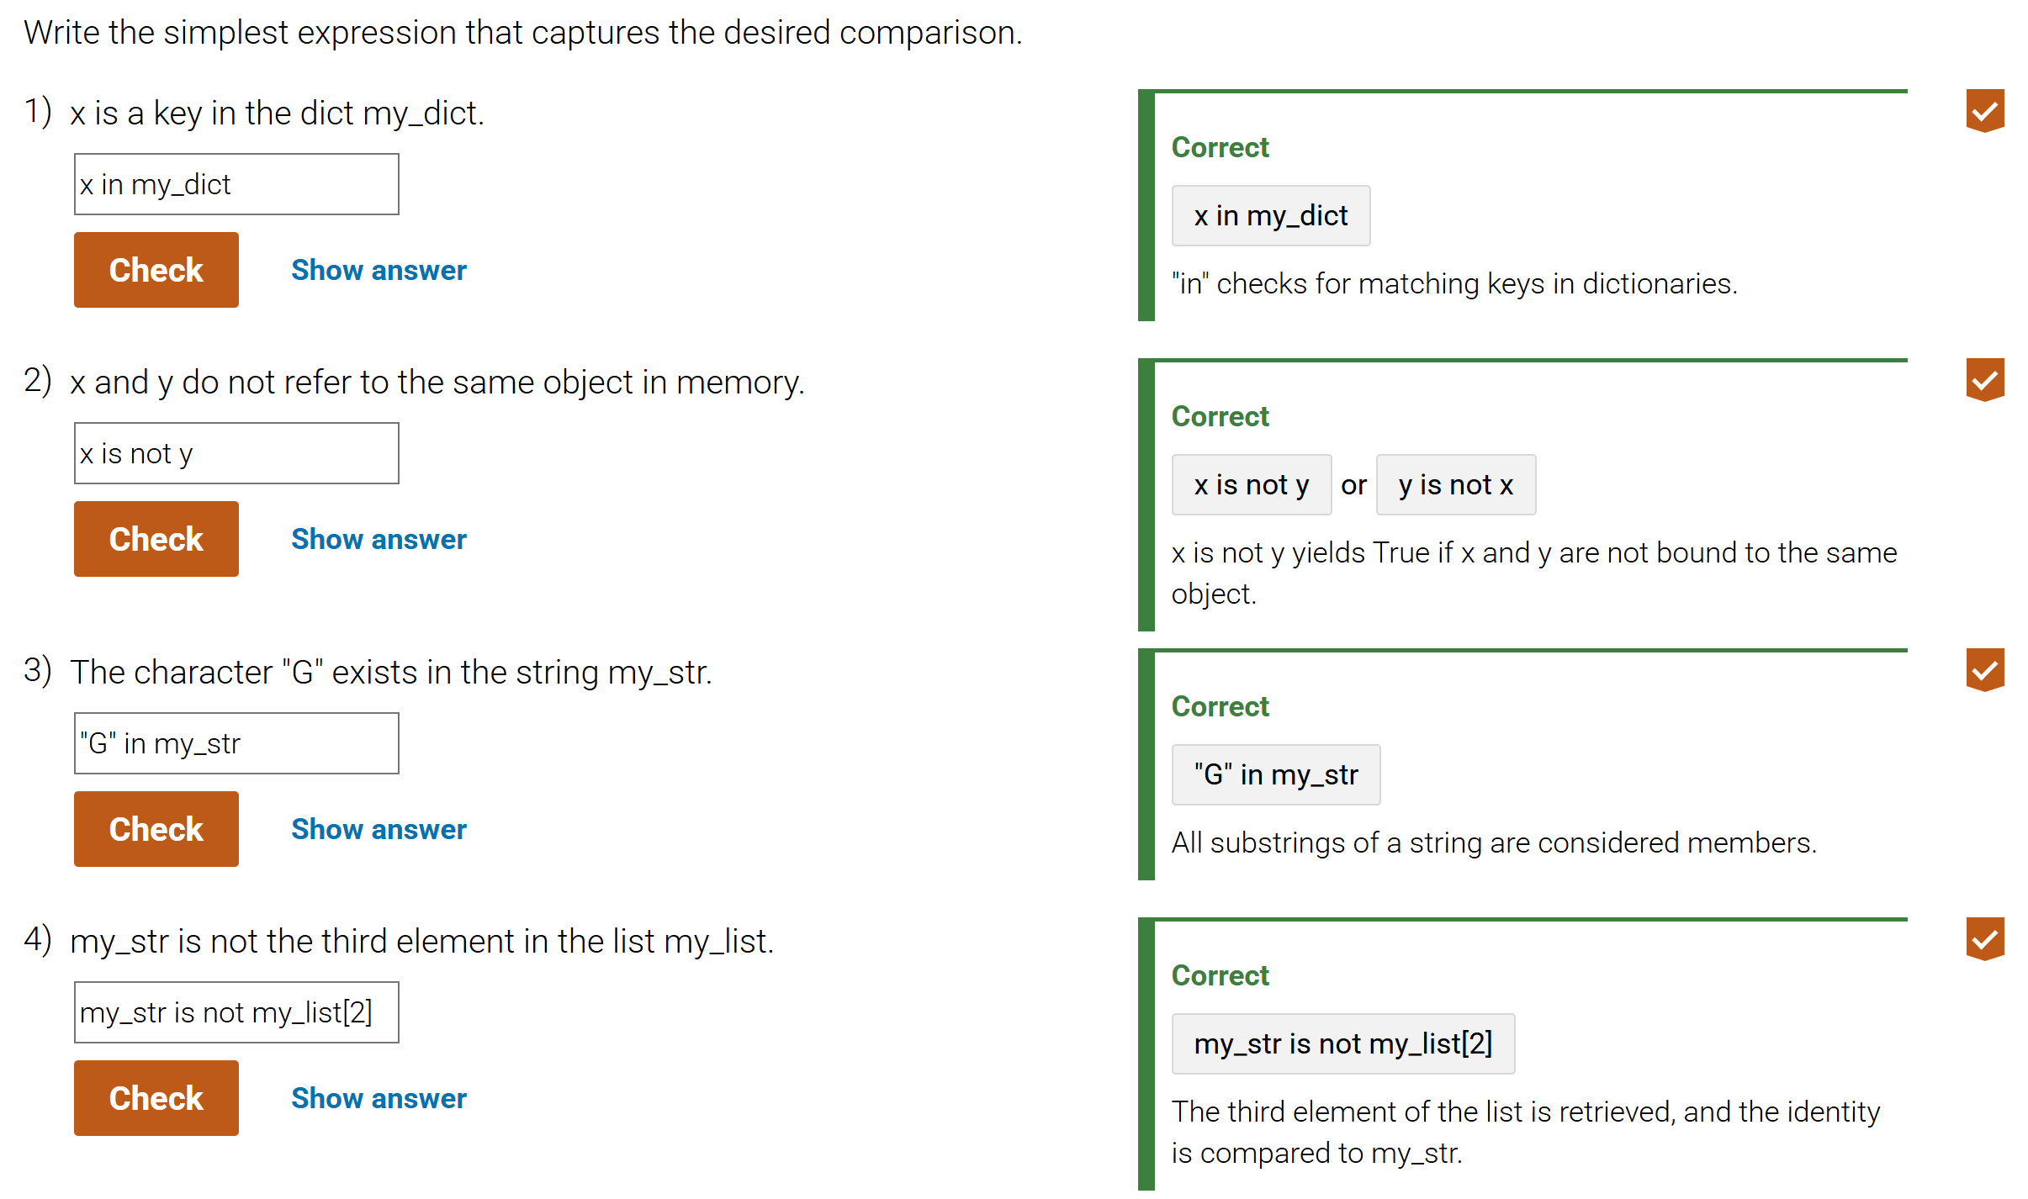
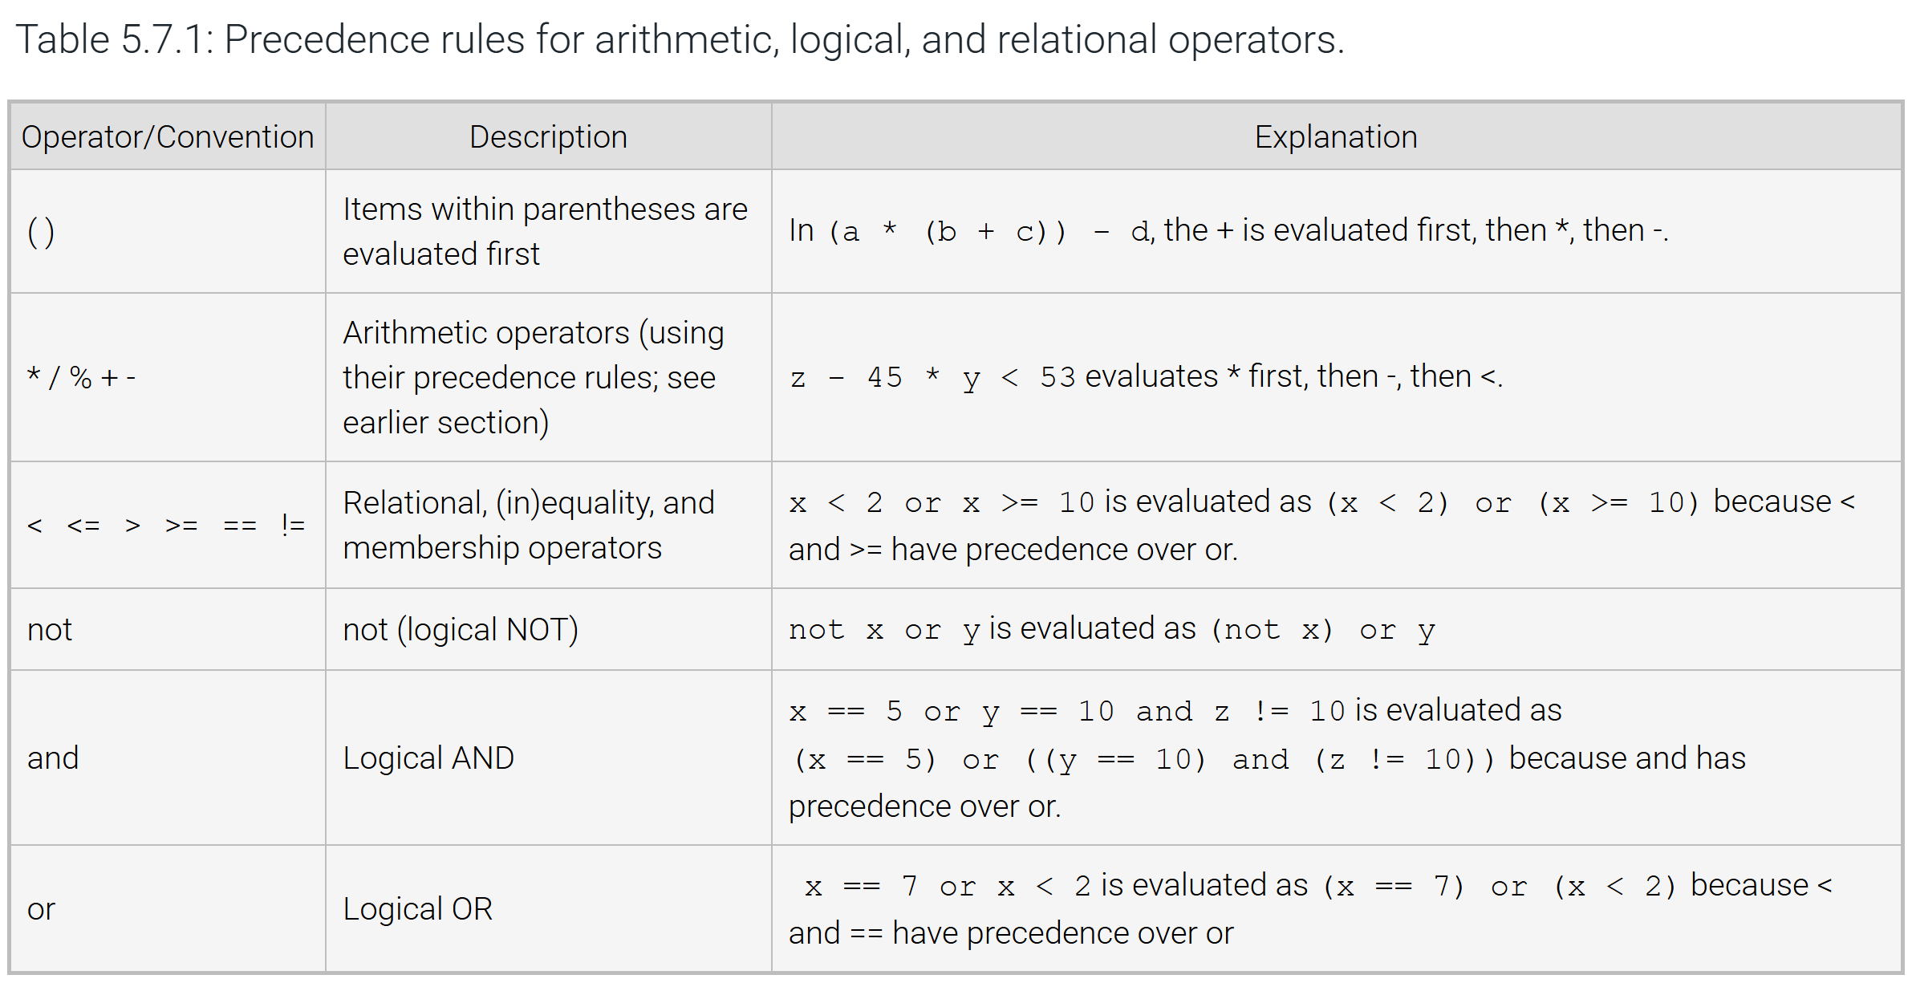
QUESTIONS TO REVISIT / COMMON PITFALL(S):
- A common error is to use = rather than == in an if-else expression, as in: if numDogs = 9:. In such cases, the interpreter should generate a syntax error.
- Another common error is to use invalid character sequences like =>, !<, or <>, which are not valid operators.
- A common error is to confuse the equivalence operator "==" and the identity operator "is", because a statement such as if x is 3 is valid syntax and is grammatically appealing.
- A good practice is to avoid using the identity operators "is" and "is not", unless explicitly testing whether two objects are identical.
- The id() function can be used to retrieve the identifier of any object. If x is y is True, then id(x) == id(y) is also True.
- A common error is to write an expression that is evaluated in a different order than expected. Good practice is to use parentheses in expressions to make the intended order of evaluation explicit.
- A common error for new Python programmers is the mixing of tabs and spaces.
ADDITIONAL READING(S) / LINKS:
N/A

